2324 BUDGET ADJUSTMENTS
202324 SCHEDULE B
Budget & Reporting
Budget & Treasury Office
202324 SCHEDULE B

Table of Contents

PART 1 – ADJUSTMENTS BUDGET 5
1. Mayor’s Report 5
2. Resolutions 6
3. Executive Summary 7
PART 2 – SUPPORTING DOCUMENTATION 31
2.1 Adjustments to Budget Assumptions 42
2.2 Adjustments to Budget funding 42
2.3 Municipal Manager’s Quality Certificates 45

Glossary

Adjustments budget – Prescribed in section 28 of the MFMA.
The formal means by which a municipality may revise its annual budget during the year.
Allocations – Money received from Provincial or National Government or other municipalities.
Budget – The financial plan of the Municipality.
Budget related policy – Policy of a municipality affecting or affected by the budget, examples include tariff policy, rates policy and credit control and debt collection policy.
Capital expenditure - Spending on assets such as land, buildings and machinery. Any capital expenditure must be reflected as an asset on the Municipality’s balance sheet.
Cash flow statement – A statement showing when actual cash will be received and spent by the Municipality. Cash payments do not always coincide with budgeted expenditure timings. For example, when an invoice is received by the Municipality it is shown as expenditure in the month it is received, even though it may not be paid in the same period.
DORA – Division of Revenue Act. Annual legislation that shows the total allocations made by National to Provincial and local government.
Equitable share – A general grant paid to municipalities. It is predominantly targeted to help with free basic services.
Fruitless and wasteful expenditure – Expenditure that was made in vain and would have been avoided had reasonable care been exercised.
GFS – Government Finance Statistics. An internationally recognised classification system that facilitates like for like comparison between municipalities.
GRAP – Generally Recognised Accounting Practice. The new standard for municipal
accounting.
IDP – Integrated Development Plan. The main strategic planning document of the municipality
MBRR – Local Government: Municipal Finance Management Act (56/2003): Municipal budget and reporting regulations April 2009
MFMA – The Municipal Finance Management Act – No. 56 of 2003. The principle piece of
legislation relating to municipal financial management.
MTREF – Medium Term Revenue and Expenditure Framework. A medium term financial plan, usually 3 years, based on a fixed first year and indicative further two years budget allocations. Also includes details of the previous and current years’ financial position.
Operating expenditure – Spending on the day to day expenses of the Municipality such as salaries and wages.
Rates – Local Government tax based on the assessed value of a property. To determine the rates payable, the assessed rateable value is multiplied by the rate in the rand.
SDBIP – Service Delivery and Budget Implementation Plan. A detailed plan comprising quarterly performance targets and monthly budget estimates.
Strategic objectives – The main priorities of the Municipality as set out in the IDP. Budgeted spending must contribute towards the achievement of the strategic objectives.
Unauthorised expenditure – Generally, spending without, or in excess of, an approved budget.

Virement – A transfer of budget.
Virement policy - The policy that sets out the rules for budget transfers. Virements are normally allowed within a vote. Transfers between votes must be agreed by Council through an Adjustments Budget.
Vote – One of the main segments into which a budget. In Harry Gwala District Municipality means a directorate level.

PART 1 – ADJUSTMENTS BUDGET

Mayor’s Report

INTRODUCTION
The adjustment budget seeks to rectify issues identified in the mid-year assessment of the financial results as well as the inclusion of additional allocations. It is drafted in terms of section 28 of the MFMA and seeks to adhere to the stipulations of specifically section 28(2) of the MFMA

BACKGROUND
In accordance with section 28 of the Municipal Finance Management Act, No 56 of 2003 (MFMA) a municipality must revise its approved annual budget through an adjustments budget, in the following circumstances:
- To appropriate additional revenues that have become available over and above those anticipated in the annual budget, but only to revise or accelerate spending programmes already budgeted for.
- To authorise the utilisation of projected savings in one vote towards spending under another vote.
- To authorise the spending of funds that were unspent at the end of the past financial year where the under-spending could not reasonably have been foreseen at the time to include projected rollovers when the annual budget for the current year was approved by the Council.
- To correct any errors in the annual budget.
In line with the MFMA, the 2023/24 approved Budget has now been adjusted. The adjustment has been mainly necessitated as a result of the following:
- To appropriate the reduction of revenues that have been deducted from the annual budget, but only to revise spending programmes already budgeted for
- The need to authorise the spending of unspent funds at the end of the 2023/2024 financial year.
- The Adjustments Budget reaffirms the Municipality’s commitment to achieve the service delivery targets and performance indicators as reflected in the approved service delivery and budget implementation plan.
The process of budget adjustment also allows us to assess the state of our finances, reflect on the current challenges and design therapeutic measures that will turn around the finances of Harry Gwala District Municipality.

The attention is given to the department of Water Services operational efficiency with considerable emphasis on operations and maintenance cost control. The Water services budget has seen an increase of R 4, 7milllion to adjusted budget of R265, 2million due to the nature of the operations and maintenance undertaken under this department, while most departments have seen a decrease in their budgets followed by Corporate Services due to Security, fuel and day to day running costs of the municipality.

In preparing the adjustment budget priority had to be given to Water Services Department by making budget available for the next five months, this is largely due to prioritization of repairs and maintenance of the aging water and sanitation infrastructure that is now degenerating putting more strain on the cash flow of the municipality.

Resolutions

It is recommended that the Harry Gwala District Municipal Council;
  - Approves the adjustments budget and consolidated adjustments budget for the financial year 2023/2024, as set-out in the schedules contained in Section 4, be approved:
  - Approves any adjustments permitted in terms of Section 28 (2) of the Act,
  - Approves the revisions to the monthly and quarterly service delivery targets and performance indicators in the service delivery and budget implementation plan, if any, to correspond with the approval of the adjustments budget.
  - Notes the Provincial Treasury comments and their effect on the Adjustments budget

Executive Summary

The application of sound financial management principles for the compilation of the municipality’s financial plan is essential and critical to ensure that the municipality remains viable and that the municipality services are provided sustainably, economically and equitably to all communities.

It is critical to note that this report s28 MFMA report has been prepared as informed by the Midyear Performance assessment report presented to Council in January 2024 in terms of s72 of the MFMA a report that was also submitted to the National and Provincial in terms of s72 (1) (b) MFMA.

The Adjusted consolidated revenue has increased by R24, 1m (3%) from R927, 3m to R951, 4m and parent increased from R909, 6 to R933, 8m. This upward adjustment is mainly due to the following major contributing factors;

- Interest Earned-External Investments R13, 8m.
- Interest Earned-Outstanding Debtors R 3, 7m.
The downward adjustment is mainly due to the following contributing factor.
- Service charges - sanitation revenue R1, 6m
- Service charges - water revenue R 7, 4m
- Transfers Operational R 14, 7m.
- Expanded Public Works Programme R345k
- Own Revenue R 291k

The Adjusted operations budget is R684, 1m having increased by R22, 4million from the original budget of R706, 5million. The item below expenditure by type had the major movements:

- Employee Related Costs: The municipality is spending according to what was anticipated. Therefore, no adjustment budget needed.

- Inventory Consumed: A variance of R6, 9million or 24 per cent due to an under-estimation of budgeted bulk water purchases. The revised bulk water purchases and inventory water increased from the original budget of R 28, 4million to adjusted budget of R 35, 3million for the 2023/2-24 financial year.

- Contracted Services: A variance of R 10, 3million or 8 per cent due to a limited funds therefore the original budget was underestimated. The revised budget includes upward adjustment of repairs and maintenance and security.

- Other expenditure or Operating Costs: A negative variance of R5, 3 million or 6per cent due to a limited funds therefore the original budget was underestimated. The revised operating costs expenditure of R 5, 3million is 6 per cent more than the original budget of R 89, 7million for the current financial year.

The following line items had major movements.
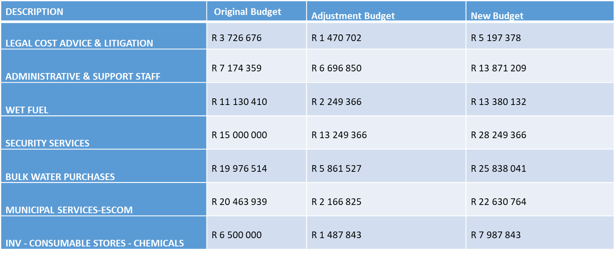
Vf To this end much attention is given to the department of Water Services. Water services department also hosts the largest percentage of the municipality’s labour force. Water Services department seen an upward adjustment by R 4, 7million for operations and Maintenance.
The capital budget has increased from R305, 4million to R316, 2million. This is mainly attributable to the downward adjustment of the following grants.

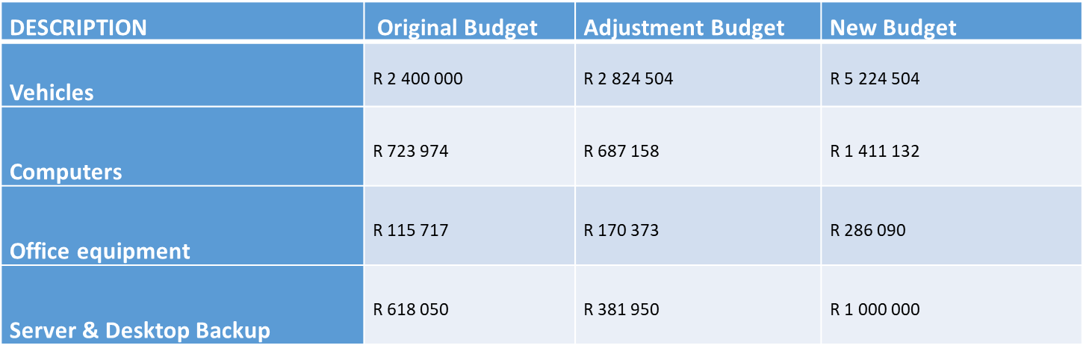
As the municipality is in the process of reducing costs, there is an amount of R1 400 000 that is set aside to procure the Vehicle for Speaker and Deputy Mayor, furthermore, the municipality decided not to renew the contract of leasing the municipal vehicles in that way the municipality is going save a lot of money.

The below items is mainly attributable to the additional/reduction of the following grants;

- Municipal Infrastructure Grant Rollover: R21, 1million
- Municipal Infrastructure Grant Reduction: R16, 1million
- Water Services Infrastructure Grant: R 10million

Budget Summary vs Adjusted Summary
TABLE B 1 CONSOLIDATED ADJUSTMENT BUDGET SUMMARY
Table B1 below provides a summary of the budget adjustment of the municipality and is unpacked in the sections that follow.

Table B1 Cont…..

TABLE B2 ADJUSTMENT BUDGET FINANCIAL PERFORMANCE
Schedule B2 is the Expenditure by standard classification presents the adjustment expenditures by the departments.

The parent revenue has increased by 3% from R909, 6million originally approved budget to R933, 8million. This upward adjustment is mainly due to following major contributing factors;
- Service charges - water revenue: Decreased by R7, 4million from R61, 1million to R53, 7million. A decrease is due to underperformance in the billing for the mid-year and installation of smart meters to all areas within the municipality. The revised revenue of R 53, 7million is 12% less than the original budget of R 61, 1million for the 2023/2024 financial year.
- Service charges - sanitation revenue: Adjusted downward by R1, 6m from R15million to R13, 4million. An decrease is as a result of an overestimation of budgeted operating revenue.
- Interest earned - external investments: A positive variance of R 13 .8million or 272% due to Slow expenditure on capital expenditure on capital grants.
- Interest earned - outstanding debtors: A positive variance of R3 .7million or 31% The variance resulted from the nonpayment for services by the consumers resulting in a higher than anticipated consumer debtors’ balance.

- Own revenue- A negative variance of R 290k or 34% due to a decrease in sale of tender documents and clearance certificates.

Chart 1: Adjusted Revenue Budget by Standard Classification

Parent Operational expenditure has increased by 3% to R688, 5million. This increase is largely attributed to the water services department which is responsible for repairs and maintenance.
- Inventory Consumed: A variance of R6, 9million or 24 per cent due to an under-estimation of budgeted bulk water purchases. The revised bulk water purchases and inventory water increased from the original budget of R 28, 4million to adjusted budget of R 35, 3million for the 2023/2-24 financial year.

- Contracted Services: A variance of R 10, 3million or 8 per cent due to a limited funds therefore the original budget was underestimated. The revised budget includes upward adjustment of repairs and maintenance and security.

- Other expenditure or Operating Costs: A negative variance of R5, 3 million or 6per cent due to a limited funds therefore the original budget was underestimated. The revised operating costs expenditure of R 5, 3million is 6 per cent more than the original budget of R 89, 7million for the current financial year.
Chart 2: Adjusted Operation Budget by Standard Classification

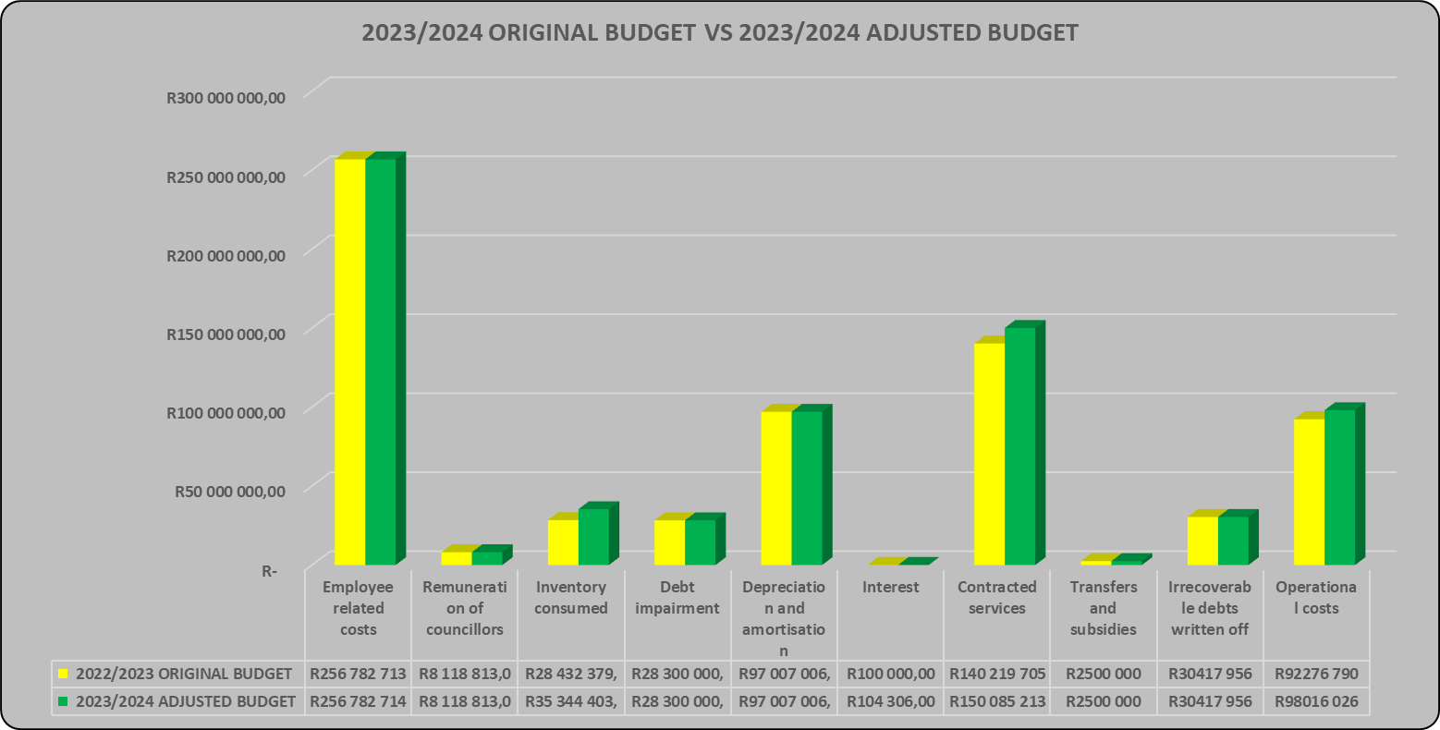

TABLE B3 ADJUSTMENT BUDGET FINANCIAL PERFORMANCE

Table B3 presents the same information as the table above, the difference being that it’s by Municipal vote.

Chart 3: Adjustment budget financial performance

The graph above presents the adjustment budget expenditure by type.
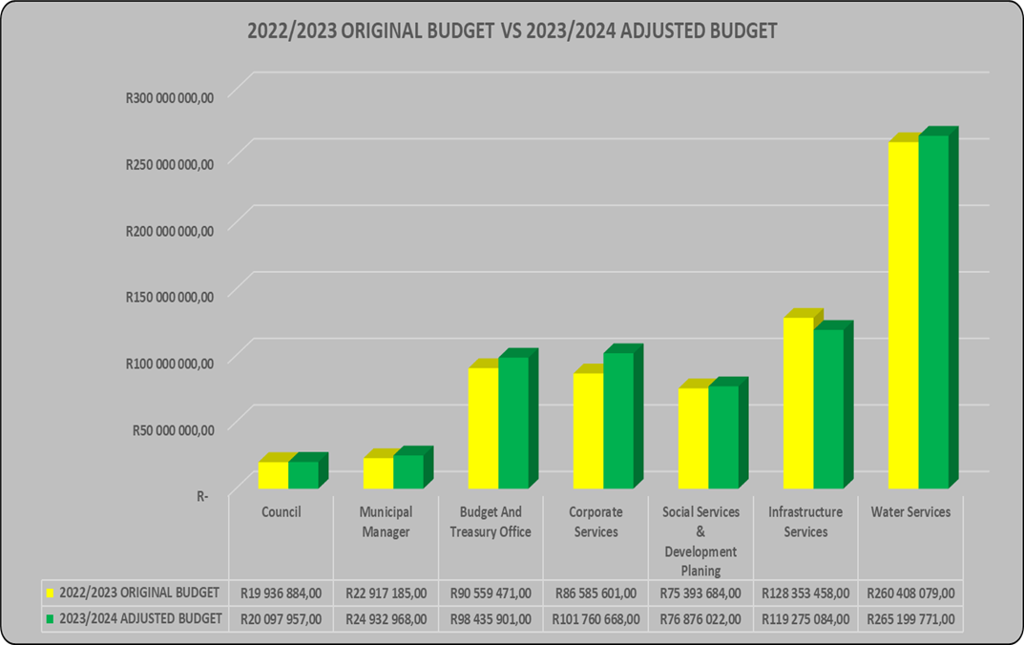
Some major differences above are caused by the cash flow constraint facing the municipality as a result of the limited revenue, while most departments have not adjusted their budgets, Water Services has seen an increase due to the nature of the operations and repairs and maintenance undertaken under water services department followed by Corporate Services due to day to day operations of the municipality. Water Services Department also hosts the largest percentage of the municipality’s labour force

The graph above presents the adjustment budget expenditure by vote.
TABLE B4 ADJUSTMENT BUDGET FINANCIAL PERFORMANCE
This schedule provides information on the adjustment revenue by source and adjustment operational expenditures by type.
TABLE B5 ADJUSTMENT CAPITAL EXPENDITURE BUDGET BY VOTE AND FUNDING
Schedule B5 below reports on the adjusted capital expenditures by departments (municipal vote) and also by standard classification. The bottom part of the schedule looks at the funding sources of the capital projects.

Chart 6: Capital Expenditure by Vote

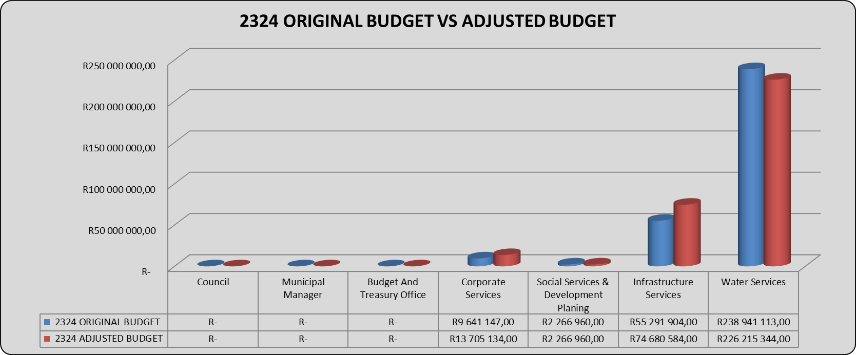

The capital budget has increased from R305, 4million to R316, 2million. The municipality adjusted the budget upwards due to municipal vehicles, MIG approved rollover and installation of bulk water meters. A upward adjustment amounting to R10, 7million. There is also a downward adjustment due to DORA reduction on MIG AND WSIG.

TABLE B6 ADJUSTMENTS BUDGET FINANCIAL POSITION
Table C6 displays the adjustment budget financial position of the municipality
TABLE B7 ADJUSTMENTS BUDGET CASH FLOWS

TABLE B8 CASH-BACKED RESERVES / ACCUMULATED SURPLUS RECONCILIATION

TABLE B9 ASSET MANAGEMENT

TABLE B10 BASIC SERVICE DELIVERY MEASUREMENT

PARENT TABLES

TABLE B 1 PARENT ADJUSTMENT BUDGET SUMMARY
Table B1 below provides a summary of the budget adjustment of the municipality and is unpacked in the sections that follow

Table1 cont…

TABLE B2 ADJUSTMENT BUDGET FINANCIAL PERFORMANCE
Schedule B2 is the Expenditure by standard classification presents the adjustment expenditures by the departments.

TABLE B3 ADJUSTMENT BUDGET FINANCIAL PERFORMANCE
Table B3 presents the same information as the table above, the difference being that it’s by Municipal vote

TABLE B4 ADJUSTMENT BUDGET FINANCIAL PERFORMANCE
This schedule provides information on the adjustment revenue by source and adjustment operational expenditures by type
TABLE B5 ADJUSTMENT CAPITAL EXPENDITURE BUDGET BY VOTE AND FUNDING
Schedule B5 below reports on the adjusted capital expenditures by departments (municipal vote) and also by standard classification. The bottom part of the schedule looks at the funding sources of the capital projects.
TABLE B6 ADJUSTMENTS BUDGET FINANCIAL POSITION
Table C6 displays the adjustment budget financial position of the municipality

TABLE B7 ADJUSTMENTS BUDGET CASH FLOWS

TABLE B8 CASH-BACKED RESERVES / ACCUMULATED SURPLUS RECONCILIATION

TABLE B9 ASSET MANAGEMENT

PART 2 – SUPPORTING DOCUMENTATION

Adjustments to Budget Assumptions

There have not been major shifts in the budget assumptions. However, the few points noted below are work noting.
External factors: The economic slowdown as shown by the further declines in economic growth figures, the rising cost of living due to increases in the cost of borrowing and the high unemployment levels, financial resources are limited due to reduced payment levels by consumers. The latest figures released by the Census also show a decline in district population due to migration. This has resulted in declining cash inflows, which has necessitated major budgeted expenditure cuts to ensure that cash outflows remain within the affordability parameters of the district’s finances.

Adjustments to Budget funding

Cash flow constraints still continue to affect the financial sustainability of the municipality as the municipality is largely grant dependent. This high grant dependency ratio (of over 93%) means that the municipality’s operations are highly sensitive to non-payment by consumers. The increasing water & sanitation infrastructural assets also tend to burden the operations budget in the form of high operations and maintenance costs.

Table SB 7 below provides details of the Government Grants and Subsidies differentiated between National & Provincial Governments.

The total adjusted Operational Government grant allocations are as follows;
- National Government R 479million

The operating transfers original budget was R 493, 8million, it was reduced by R14, 7million due to reduction for Expanded public works programme of R345k and Municipal Infrastructure Grant that was allocated for Assets and repairs and Maintenance and the budget was taken back to capex.

The total consolidated adjusted Operational Government grant allocations are as follows;
- National Government R 479million

While the adjusted Capital Funding are as follows;
- National Government R 351, 9million

The adjusted budget is R 351, 9million from the original budget of R321, 3million. The upward adjustment is as a result of R14, 7 million from operating transfers, Reduction of Municipal Infrastructure grant amounting to R16, 1million and Water Services Infrastructure Grant that was also reduced as per Division of Revenue Amendment Bill dated October 2023 reference B33-2023. There was also an increase of R21, 1million rollover that was approved in terms of section 21(2) of the 2022 Division of Revenue Amendment Act, (Act No. 15 of 2022) (DoRA) letter dated 31 August 2023 DC 43/3.

Municipal Manager’s Quality Certificates

I, Gamakulu Ma’art Sineke, Municipal Manager of Harry Gwala District Municipality, hereby certify that the adjustments budget and supporting documentation have been prepared in accordance with the Municipal Finance Management Act and the regulations made under that Act, and that the adjustments budget and supporting documentation are consistent with the Integrated Development Plan of the municipality.

Print name: Gamakulu Ma’art Sineke

Municipal Manager of Harry Gwala District Municipality (DC43)

Signature: ___________________

Date 27 February 2024

